*/

class TestController extends Controller {

public function actionIndex()

{

$post = new Post();

$post->title = 'links test';

$post->text = 'before <http://www.yiiframework.com/> after'; $post->save();

return $this->renderContent(Html::tag('pre', VarDumper::dumpAsString( $post->attributes

)));

}

}

3. That is it. Now, run test/index. You should get the following result:

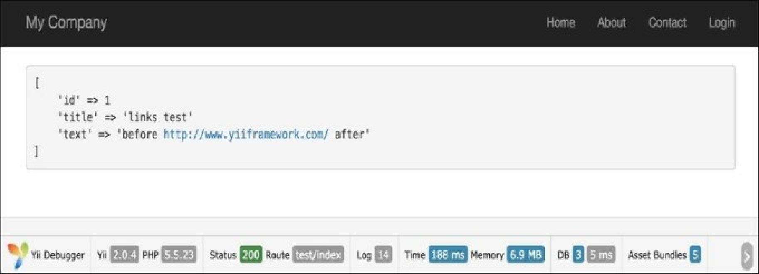

How it works...

The beforeSave method is implemented in the ActiveRecord class and executed just before saving a model. Using a regular expression, we replace everything that looks like a URL with a link that uses this URL and call the parent implementation, so that real events are raised properly. In order to prevent saving, you can return false.

See also

• [For further information, refer to http://www.yiiframework.com/doc-2.0/guide-db-active-](http://www.yiiframework.com/doc-2.0/guide-db-active-record.html%23active-record-life-cycles) record.html#active-record-life-cycles.

• The Working with events recipe in Chapter 1, Fundamentals

• The Automating timestamps recipe

• The Setting up an author automatically recipe

• The Setting up a slug automatically recipe